NVIDIA Settings

  - Ansly Azorie
Contents
NVIDIA 3
NVIDIA Control Panel 3D settings 3
Commands 3
CoProcManager 7
Checking processor speed 7
1. Satisfying solution: 7
2. Old setting: 9
3. Old setting: 10
4. Old setting: 12
5. Old setting: 14

NVIDIA

NVIDIA Control Panel 3D settings
Open:
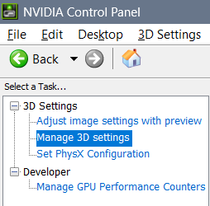

Commands
Ambient Occlusion:
- Off – All possibilities
- Performance – User doesn’t notice the data, but sometimes it sets user free with other “performance” settings (maybe if user needs Anisotropic filtering set on “2x”)
- Quality – User notices the data
Anisotropic filtering:
- Off – all possibilities
- 2x – user help
- 4x – user system
- 8x – user only
- 16x – all possible published system
Antialiasing – FXAA: On – cooperation in between user and display (with user thoughts involved)
Antialiasing mode:
- Application-controlled: Applications can pull the system or not
- Off: Both variants
- Enhance the application setting: Work in each of the applications individually
- Override any application setting: Work only thinking on one thing in all of the applications
Antialiasing Setting:
- application controlled
- 2x – user help
- 4x – user system
- 8x – work with user
Antialiasing – Transparency:
- Off: Any kind of speed
- Multisample: extremely slow speed of showing data
- 2x – supersample: slow showing of data
- 4x – supersample: fast showing of data
- 8x – supersample: extremely fast showing of data
Background Max Application Frame Rate:
- I believe regular speed and finest is: 35 FPS
CUDA – System Fallback Policy:
  - I find more natural Quantum Wall only
- Driver Default: Both Display and Quantum Wall
- Prefer System Fallback: Quantum Wall
- Prefer No System Fallback: Display
Low Latency Mode:
- Off: User knows nothing
- Ultra: User has available insight in the data of coded Quantum Wall
Max Application Frame Rate:
- Regular speed and finest speed is: 35 FPS
- Regular speed for slow PC: 25 FPS
- Irregular speed for PC is: 27 FPS
My suggestion is to use the mixture of the 27 FPS and 25 FPS:
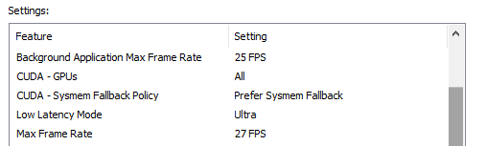
Multi-Frame Sampled AA (MFAA):
- On: Through past future (“ralloxar”)
- Off: Only “now” (at the current moment of a changeable past and future)
OpenGL GDI compatibility:
- Prefer Compatible: goes with Prefer System Fallback – Quantum Wall
- Prefer Performance: goes with Display
- Auto: goes with Display, but sometimes and with Quantum Wall
Power Management Mode:
  - I prefer Maximum Performance for enabling Quantum Wall
- NVIDIA Driver Controlled: Turns off Quantum Wall
- Prefer consistent performance: Display
- Prefer Maximum Performance: Enables Quantum Wall
Shader Cache size:
- Driver Default: Enables Quantum Wall
- Disabled: Disables Quantum Wall
- Unlimited: Enables Quantum Wall
Texture Filtering – Anisotropic Sample Optimization:
- On: Quantum Wall works normally
- Off: Quantum Wall knows to create order for work (for example)
Texture Filtering – Negative LOD bias:
- Allow – Quantum Wall data is hidden
- Clamp – Quantum Wall data is seen
Texture Filtering – Quality:
- High Quality: too strong, so Quantum Wall enables “Wishes” and behaves strangely
- Quality: Quantum Wall works fine
- Performance: Quantum Wall doesn’t work
- High Performance: Quantum Wall doesn’t work
Texture Filtering – Trilinear Optimization:
- Off: Quantum Wall works poorly
- On: Quantum Wall works fine
Threaded Optimization:
- Off: One thought at the time
- On: All thoughts are fine
Triple Buffering:
- Off: System lets user free, but this option doesn’t create sometimes a full Quantum Wall
- On: Quantum Wall Works while system holds user
Vertical Sync:
  - Works fine with: “Triple Buffering: Off”
  - I believe that by feeling of display on the level of imagining user can choose between half refresh rate or full refresh rate
- Adaptive (half refresh rate): User has lied system (on 35 Hz)
- Adaptive: I believe works not fine for me
Virtual Reality pre-rendered frames:
  - I prefer option “3D application setting” (for hired ones) or “4” for free reading
- 1: user needs to read everything from quantum wall
- 2: user reads that is interested in
- 3: user doesn’t need to read anything
- 4: user reads everything when one wishes
- 3D application setting: When something fits within the work user reads it then (option is similar to the job – so user is considered hired)
Vulkan/OpenGL present method:
- Prefer native: Quantum Wall doesn’t show data well
- Prefer Layered on DXGI Swapchain: Quantum Wall works fine

CoProcManager
- “Computer\HKEY_LOCAL_MACHINE\SOFTWARE\NVIDIA Corporation\Global\CoProcManager”

Checking processor speed
First, go to Task Manager and check the processor speed. If processor speed isn’t fine, maybe there is a chance that by editing registry values you fix the processor speed. What else can happen by editing Registry Keys? Well, PC might not recognize the graphics card, so be cautious while doing so, and first preserve the values of the Keys that you are editing, so that you can return the values to the default state…

Satisfying solution:
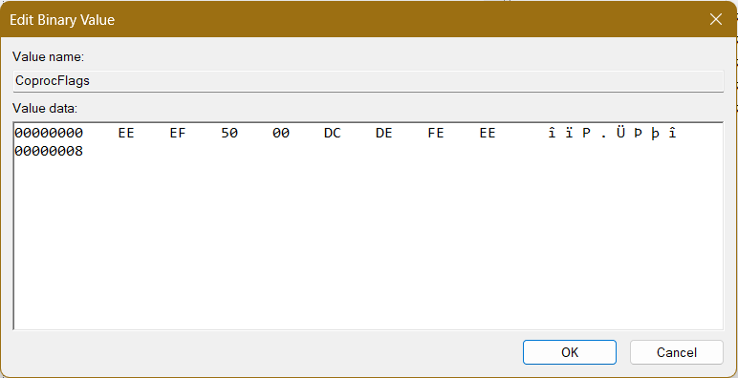
After update we had to edit full command
Besides that previous solution was simple:
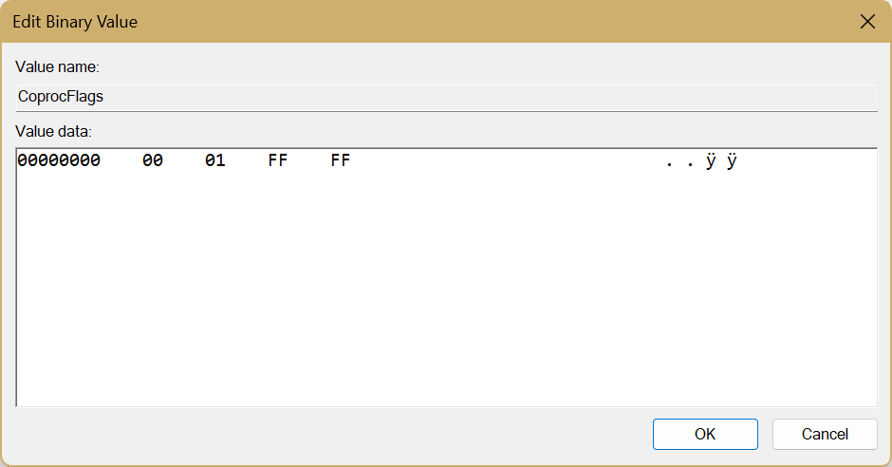
00 01 – Approaching primitive Intel chip
FF FF – Speed unknown

Old setting:
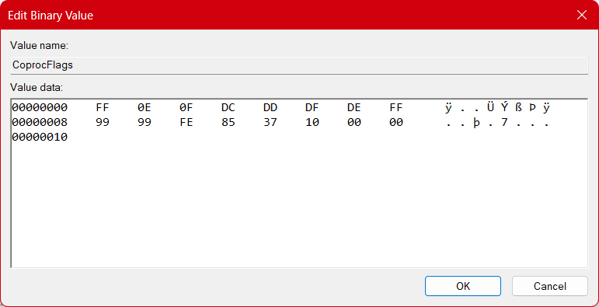
FF – Entering “All the speed” command
0E – Start from the almost fastest
0F – Work till fastest speed
DC – Entering operable commands field
DD – Entering speed commands filed
DF – Entering Slowest speed command
DE – Entering speed command
FF – Entering fastest percentage
99 99 – Fastest percentage
FE - Entering slowest percentage
85 37 – Slowest percentage
10 – Entering exiting code
00 00 – Exit code

Old setting:
- Processor utilization
With this at the beginning of the work of the graphic and wi-fi connection program as is web browser – the processor, maybe because of the poor wi-fi knows to start at 0.80 GHz but it does climb over 2.5 GHz in a later browser work…
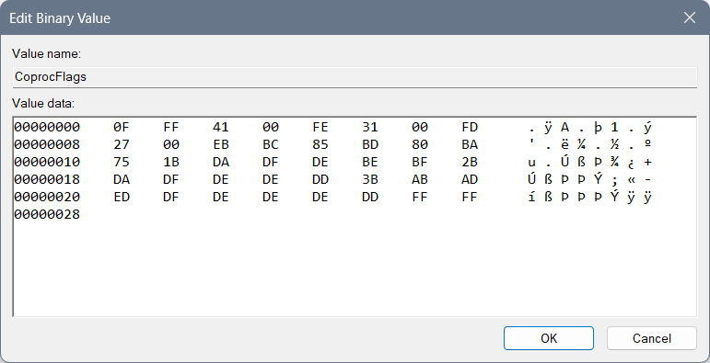
Where we used “0F” for the beginning of the speed of processor code, “FF” for first value, “FE” for the second, “FD” for the third… After “FF” is instead of “125C” or 4700GHz the maximum speed of the processor – by the Windows reduced speed of the processor. After “FE” there is the “3100”GHz second speed of processor. And after “FD” we can find the 2700 lowest speed of the processor…
Then we used the “EB” for the beginning of the coding of the utility of the processor – so there we have:
- “BC” – middle value which is 85,
- “BD” – lower value which is 80,
- “BA” – lowest value which is 75.
Then we need to code the functioning of the processor with the code that represents the changing value as in percentage of the usage of the processor when the need for work is in progress, and we can maybe do it as: “89 87 88 97 99”, but numbers we will use in file only for the speed of the processor and the utilization, so – we will do it over letters… We will code for each of the speed of the processor an extra behavior – dividing the codes with “1B”, “2B” and “3B”…
After “1B” you can find “DA DF DE BE BF” where the “D” is the beginning letter for this particular thing and we will request from the beginning of the speed which is “A” up to “F” for the processor to work as fastest as it can with letter “E” and then it can finish with “F” as a last letter…
After “2B” you can find “DA DF DE DE DD” and here everything is the same except we used the change of processor for lower value “DE” and not “BE” and we have used the extrapolation of the work of the processor of the “DD” for the purpose of shortening the speed of the processor for it to reclaim the lower speed or to change to the other class of work for example “3B”… I believe that it can be used and for the “not to repeat the same code and to complete the idea of how fast the processor will work – within previous 1B – copy from the that part what goes on after: DA DF DE”, but I am not sure about that…
After “3B” you can find the “AB AD ED DF DE DE DE DD” which starts with “A” for the purpose of starting the processor, connecting it’s second speed with letter “B”, then going to the “D” and climbing the processor speed from “A” to “E” – or actually “ED” then going from that state to the “DF” then to “DE” and then we would use the “DD” for the slowing down of the processor…
And in the end you can find the “FF FF FF FF” until the end of the line for empty line…

Old setting:
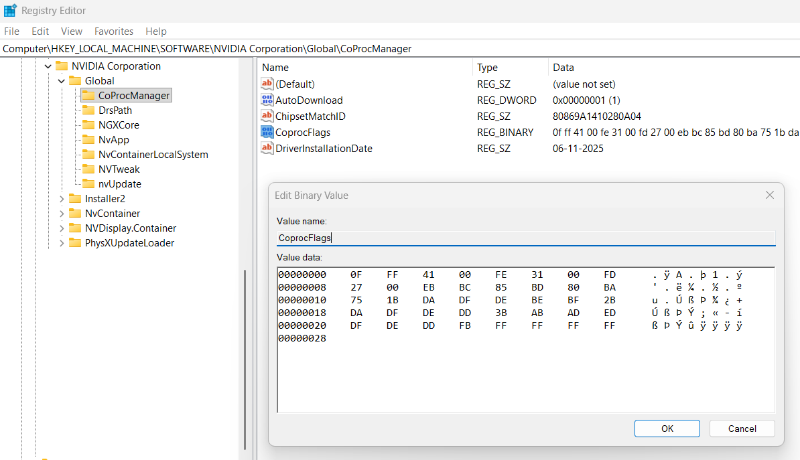
Where we used “0F” for the beginning of the speed of processor code, “FF” for first value, “FE” for the second, FD for the third… After “FF” is instead of “125C” or 4700GHz the maximum speed of the processor – by the Windows reduced speed of the processor. After “FE” there is the “3100”GHz second speed of processor. And after “FD” we can find the 2700 lowest speed of the processor… Then we used the “EB” for the beginning of the coding of the utility of the processor – so there we have:
- “BC” – middle value which is 85,
- “BD” – lower value which is 80,
- “BA” – lowest value which is 75.
Then we need to code the functioning of the processor with the code that represents the changing value as in percentage of the usage of the processor when the need for work is in progress, and we can maybe do it as: “89 87 88 97 99”, but numbers we will use in file only for the speed of the processor and the utilization, so – we will do it over letters… We will code for each of the speed of the processor an extra behavior – dividing the codes with “1B”, “2B” and “3B”…
After “1B” you can find “DA DF DE BE BF” where the “D” is the beginning letter for this particular thing and we will request from the beginning of the speed which is “A” up to “F” for the processor to work as fastest as it can with letter “E” and then it can finish with “F” as a last letter…
After “2B” you can find “DA DF DE DD” and here everything is the same except we used “DD” for the purpose of: “not to repeat the same code and to complete the idea – copy from the first part what goes on after: DA DF DE”…
After “3B” you can find the “AB AD ED DF DE DD” which starts with “A” for the purpose of starting the processor, connecting it’s second speed with letter “B”, then going to the “D” and climbing the processor speed from “A” to “E” – or actually “ED” then going from that state to the “DF” then to “DE” and then we would use the “DD” for the repeating of the previous code “DE DF”…
And it the end you can find the “FB” as a code for finishing the data file and “FF FF FF FF” until the end of the line for empty line…

Old setting:
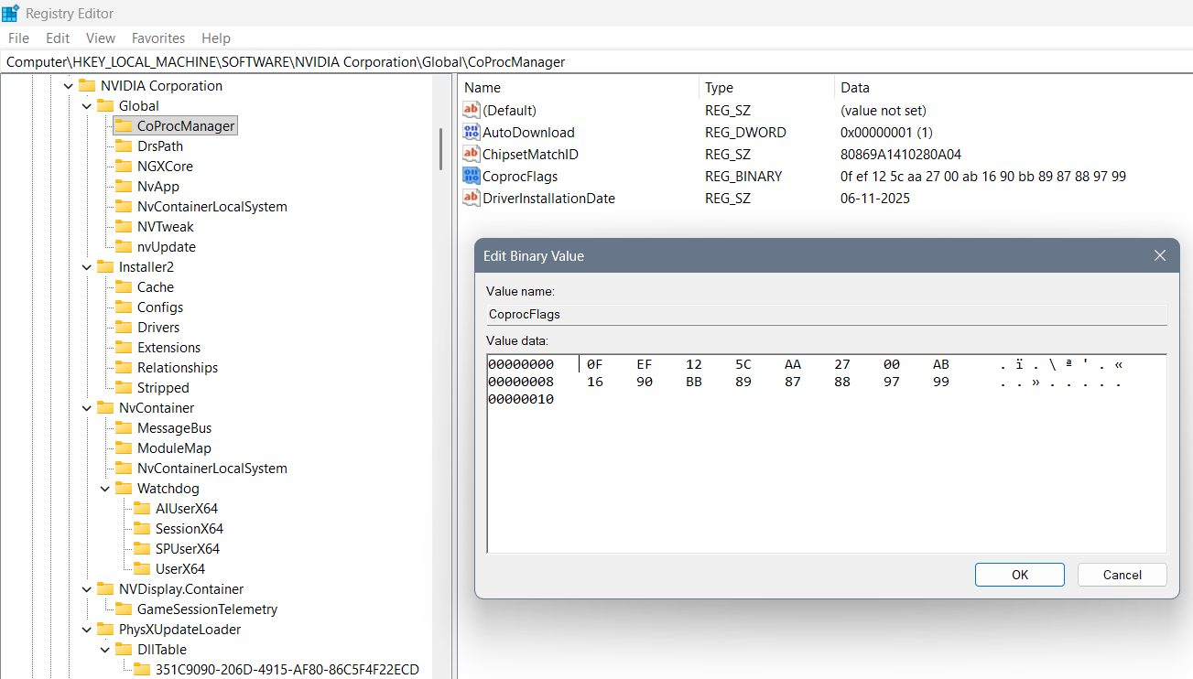
Where we used “0F” for the beginning of the code, “EF” for 3 values that are coming, “AA”, “AB” as their separators of better and worse option… In between “EF” and “AA” is a “125C” or 4700GHz the maximum speed of the processor. In between the “AA” and “AB” we can find the 2700 the middle speed of the processor… In between the “AB” and “BB” we can find the lowest boundary of the processor “1690” representing 1690GHz… In the end we used “BB” for the beginning of the coding of the processor – how it should work… The last code represents the changing value as in percentage of the usage of the processor when the need for work is there: 89 87 88 97 99…
